Darcy Harper and Katheryn Umanzor
Fall 2024
ITEC 3200
Wedding Dinner Planner

ITEC 3200
Executive Summary
Objective
This database is designed to assist wedding venues in organizing and storing essential information for couples hosting their wedding dinners. It includes details about the couples, menus, rooms, and waitstaff, streamlining the planning process.
Goals
The primary goal of this database is to provide wedding venues with an efficient and user-friendly tool for storing and retrieving the essential wedding dinner information. Queries will be implemented to facilitate the quick retrieval of details about couples, menus, rooms, and waitstaff, enabling seamless event planning.
Solution
The database solution involves interconnected tables that store and manage the required information. These tables include Couple, Menu, Room, Waiter, and Waiter_has_Room. Relationships between the tables will enable the creation of queries to support comprehensive wedding dinner planning.
It will be implemented in SQL using MySQL Workbench.
Benefits to Users
This database will significantly enhance the ability of wedding venues to track and manage all necessary details for hosting wedding dinners. By centralizing and organizing data, the system ensures smooth operations and a better experience for both the venue and the couples.
Project Outline
The project will contain the following major components:
- Entity-Relationship Diagram
- Table Implementation
- Queries

ITEC 3200
Entity-Relationship Diagram

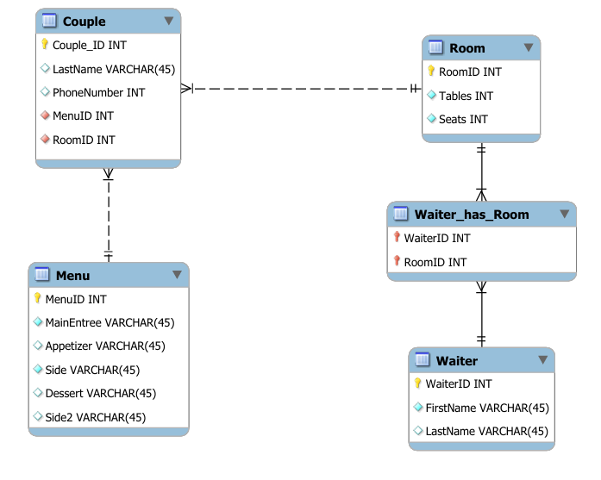

ITEC 3200
Table Implementation

Couple
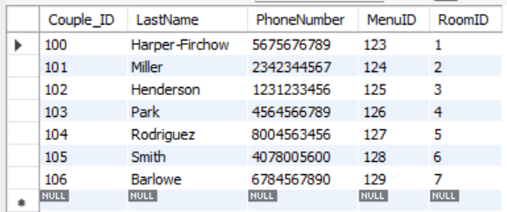

Menu
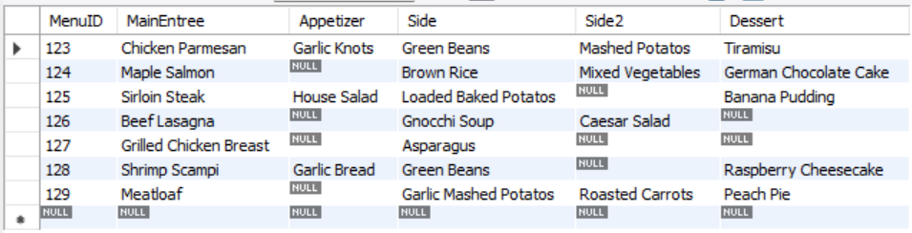

Room
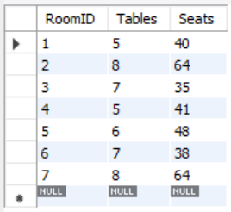

Waiter
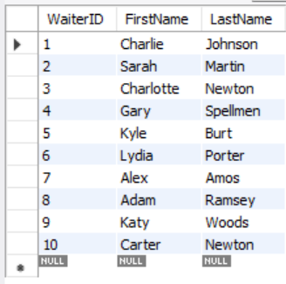

Waiter_has_room
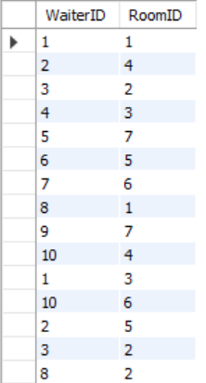

ITEC 3200
Query Implementation

Query 1
- Lists couples that have room number (100-104) or room ID < 3

Query 2
- Lists menu with an “o” in the main entrée where second side isn’t null

Query 3
- Lists waiter of ID 5 - 9

Query 4
- Lists couples with their menus and waiter IDs. Only displays the couples that have two sides.

Query 5
- Lists the total amount of equipment in each room.

Query 6
- Lists number of rooms each waiter has.

Query 7
- Lists menu ID of 123

